***EXPERIMENT NO. 7 :- Design a Programmable Digital Data Display system.***

***Circuit Diagram:-***

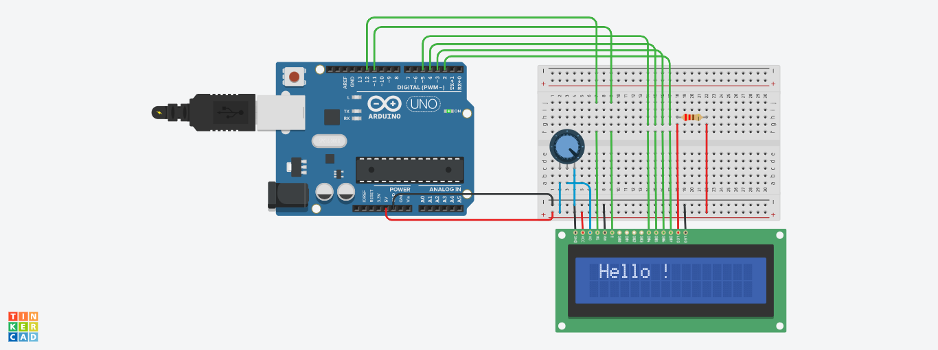

***Theory:-***

***Concept Used:-*** The concept used behind the realization of the above circuit is the principle behind LCD. A [liquid crystal display](https://www.edgefxkits.com/wireless-electronic-notice-board-by-gsm-with-user-programable-number-features) or LCD is combination of two states of matter, the solid and the liquid. Liquid crystal display screen works on the principle of blocking light rather than emitting light. LCD’s requires backlight as they do not emits light by them. We always use devices which are made up of LCD’s displays which are replacing the use of cathode ray tube. The main principle behind liquid crystal molecules is that when an electric current is applied to them, they tend to untwist. This causes a change in the light angle passing through them. This causes a change in the angle of the top polarizing filter with respect to it. So little light is allowed to pass through that particular area of LCD. Thus that area becomes darker comparing to others.

***Learning and Observations:-***

I learned how to interface a Liquid Crystal Display with an Arduino.

I also learned how to display characters on the screen. It was fun to make it.

***Problems and Troubleshooting:-***

As there are a lot of connections to make so the main problem was of connecting lcd to arduino correctly without an error. Proper connections were made with focus ,dedication and consistent efforts.

***Precautions:-***

* Take care of connections as there are a lot of connections that are to be made.
* The series and parallel connections should be made properly.
* The lcd should be connected to a resistor so to protect it from any damage.

***Learning Outcomes:-***

The learning outcome of the session was that I learned how to interface an LCD with an Arduino and attain desired result on the screen.